 | ALL SAINTS’ COLLEGE  Ewing Avenue, Bull Creek, Western Australia
 | HUMAN BIOLOGY

Year 11 2005 - Semester II Examination - Question/Answer Booklet
C.C. STUDENT NUMBER - In figures 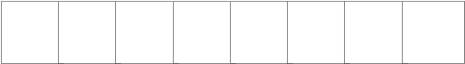

TIME ALLOWED FOR THIS PAPER
Reading time before commencing work: Ten minutes
Working time for paper: Three hours

MATERIAL REQUIRED/RECOMMENDED FOR THIS PAPER
TO BE PROVIDED BY THE SUPERVISOR
This Question/Answer Booklet
Separate Multiple Choice Answer Sheet
Standard Answer Booklet

TO BE PROVIDED BY THE CANDIDATE
Standard Items: Pens, pencils, eraser and ruler.
Special Items: A 2B, B or HB pencil for the separate Multiple Choice Answer Sheet and calculators satisfying the conditions set by the Curriculum Council.

INSTRUCTIONS TO CANDIDATES

See page 2.

IMPORTANT NOTE TO CANDIDATES
No other items may be taken into the examination room.
It is your responsibility to ensure that you do not have any unauthorised notes or other items of a non-personal nature in the examination room. If you have any unauthorised material with you hand it to the supervisor BEFORE reading any further.

SEE PAGE 2
STRUCTURE OF PAPER

Part | No. of questions available | No. of questions to be attempted. | Marks available | Your mark
I Multiple choice | 40 | ALL | 80
II Diagram and short answer questions | 9 | ALL | 80
III Extended answer questions: A  B | 2  2 | 1  1 | 20  20
Total |  |  | 200

INSTRUCTIONS TO CANDIDATES

PART I Answer ALL questions, using a 2B, B or HB pencil, on the separate Multiple Choice Answer Sheet. Do NOT use a ball point or ink pen.

PART II Should be answered in this Question/Answer Booklet. Write your answers in the spaces provided, using a blue or black ballpoint or ink pen. Draw any diagrams in pencil.

PART III Should be answered in this the Standard Answer Booklet. Use a blue or black ballpoint or ink pen. Draw any diagrams in pencil.

PART I : Multiple Choice (80 marks)

Mark your answers to Questions 1-40 on the SEPARATE MULTIPLE CHOICE ANSWER SHEET, using a 2B, B or HB pencil. If you make an error, follow the instructions given to you on the answer sheet.

Select the single correct alternative in each of the following questions.

1. Ventricular contraction causes the opening of the
A atrioventricular valves.
B semilunar valves.
C bicuspid valve.
D atrioventricular and semilunar valves.

2. The foetal heart has a structure called the foramen ovale. This structure allows blood to flow between the
A left and right atria.
B left and right ventricles.
C pulmonary artery and aorta.
D superior vena cava and pulmonary veins.

3. The double layered ‘sac’ that encloses the heart is called the
A Myocardium.
B Pericardium.
C Endocardium.
D Pleural membranes.

4. The bicuspid value closes and the aortic value opens during
A ventricular systole.
B ventricular diastole.
C atrial systole.
D both ventricular systole and diastole.

The next two questions refer to the following information.

Scientists tested two groups of five people to see if pulse rates increased with the amount of activity. Group 1 individuals were identified as Q, R, S, T and U. Group 2 individuals were identified as V, W, X, Y and Z. The pulse rate of each individual was taken on arrival at the laboratory, then group 1 individuals rested for five minutes, while group 2 individuals underwent vigorous exercise. All pulse rates were then immediately recorded. The results were tabulated as follows :

Group 1 |  |  | Group 2
Pulse rates (beats per minutes) |  |  | Pulse rates (beats per minute)
Individual | On arrival | After 5 mins | Individual | On arrival | After 5 mins
Q | 70 | 65 | V | 68 | 68
R | 68 | 70 | W | 70 | 85
S | 72 | 70 | X | 75 | 88
T | 72 | 74 | Y | 69 | 71
U | 74 | 71 | Z | 69 | 95

5. Which of the following is the experimental (independent) variable?
A Type of activity.
B Pulse rate.
C Age of individual.
D Number of students.

6. Which of the following is dependent on the experimental variable in this experiment?
A Individual's fitness.
B Smoking habits of individuals.
C Recovery time.
D Pulse rate.

7. Anaerobic respiration results in the formation of
A Carbon dioxide.
B Lactic acid.
C Triphosphate.
D Adenosine diphosphate.

8. Irritation of the anterior tibialis would result in pain that is commonly referred to as
A having ‘shin splints’.
B a rupture of the Achilles tendon.
C a pulled hamstring.
D a torn calf muscle.
9. Meiosis
A produces four identical daughter cells.
B is used for growth and repair.
C produces diploid cells.
D is involved in both spermatogenesis and oogenesis.

10. If fertilization DOES NOT occur, the corpus luteum
A degenerates after about ten days.
B produces oestrogen.
C produces another ovum.
D continues to maintain the endometrium until pregnancy occurs.
11. Nutrient and gas exchange occurs across the wall of the
A arteries.
B pulmonary vein.
C capillaries.
D both arteries and capillaries.

12. The following arteries originate from the aorta. Identify the most SUPERIOR artery.
A Hepatic artery.
B Femoral artery.
C Renal artery.
D Carotid artery.

13. The gland that secretes a fluid rich in sugars and makes up 60% of semen is/are the
A Prostate gland.
B Bulbo-urethral gland.
C Seminal vesicles.
D Testes.

14. Which of the following would be associated with the epiphysis of a long bone?
A Articular cartilage
B Medullary cavity.
C Yellow marrow.
D Compact bone.

15. A coroner’s examination of a murder victim reveals a fractured ilium. This would have been most likely caused by
A strangulation.
B a sharp blow to the chest.
C falling down a staircase.
D a gunshot wound to the head.

16. A high blood level of oestrogen
A stimulates the endometrium to thicken.
B causes ovulation.
C causes the corpus luteum to degenerate.
D occurs during menstruation.

17. Ovulation is the process by which an egg or ovum
A is released from the ovary.
B is produced in the ovary.
C implants in the uterus.
D enters the fallopian tube.

18. The cells of the developing follicle in the ovary produce
A Progesterone.
B Follicle stimulating hormone.
C Luteinising hormone.
D Oestrogen.

19. The uterus
A is penetrated by the penis during intercourse.
B allows embryonic development.
C connects the ovaries to the fallopian tubes.
D secretes oestrogen and progesterone after ovulation

20. The most important stabilizing factor in joints is/are the
A Ligaments.
B Muscle tendons.
C Shape of the bones.
D All of the above.
21. Which of the following include only those characteristics that could distinguish an African ape from a human?
A Claws, prehensile tail and 2/1/2/3 dental formula.
B Parabolic dental arcade, 2/1/2/3 dental formula and reduced canines.
C Central foramen magnum, reduced canines and large cranium.
D Parabolic dental arcade, presence of a tail and reduced canines.

22. Rough endoplasmic reticulum is
A characterised by the presence of ribosomes.
B generally arranged in layers.
C connected to the nucleus via smooth endoplasmic reticulum.
D the site where protein synthesis occurs.

23. Which of the following is NOT a characteristic of prophase?
A The chromosomes become visible.
B The centrioles form spindles.
C The chromosomes have replicated.
D The nuclear membrane has reformed.

24. Smooth muscle tissue
A is always attached to the skeleton.
B contains many nuclei in each cell.
C forms the walls of the heart.
D is found in the walls of the veins.

25. A student is observing bacteria using a microscope. The field of view at low power (100x) is 2mm and the bacteria are approximately 50 micrometres in size. She switches the objective lenses to 40x making a total magnification of 400x. The field of view and the bacteria size would now be
A 500 and 50 micrometres respectively.
B 1000 and 50 micrometres respectively.
C 50 and 10 micrometres respectively.
D 500 and 10 micrometres respectively.

26. Examples of connective tissue would include
A blood, bone and cartilage.
B bone, cartilage and epithelium.
C muscle, adipose and bone.
D bone, muscle and adipose.

27. A synovial joint would be found between the following pairs of bones EXCEPT
A two phalanges.
B the tibia and femur.
C two sacral bones.
D the ulna and the humerus.

28. Carbon dioxide transport in the blood occurs mainly by
A the platelets.
B the erythrocytes.
C forming bicarbonate ions.
D the plasma.

29. During the process of inspiration the
A diaphragm rises.
B ribs move downward and outward.
C size of the thoracic cavity decreases.
D pressure inside the thoracic cavity decreases.

30. Atherosclerosis is caused by
A the deterioration of cardiac tissue.
B the accumulation of cholesterol, calcium and fat in the heart.
C a build up of fatty deposits in the arteries.
D a swelling inside the coronary artery.

Use the following graph to answer the question below.

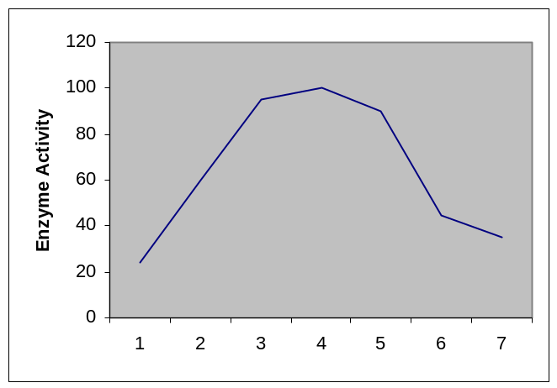

31. The optimal enzyme activity occurs at pH
A 7.
B 4.
C 1 to 7.
D 3 to 5.

32. Which of the following ‘pathways’ would sperm cells encounter after entering the vagina?
A Cervix-ovary-uterus.
B Ovary-urethra-uterus.
C Cervix-uterus-oviduct.
D Ovary-oviduct-uterus.

33. The oral contraceptive, ‘the pill’, is similar in its action to
A oestrogen only.
B oestrogen and progesterone.
C follicle stimulating hormone and oestrogen.
D progesterone.

34. Brachiation means
A using the limbs to grasp objects.
B five digits on each limb.
C a clinging and climbing action.
D using the forelimbs to swing from branch to branch.

35. Which of the following primates would NOT be included in the classification group Anthropoid?
A Lemur.
B Gibbon.
C New World Monkey.
D Baboon.

36. Which of the following skeletal features enhance bipedalism?
A The heel bone is small.
B The pelvis is narrow and long.
C The femur bones are long.
D The foramen magnum is located towards the back of the skull.

Using the following diagram answer the question 37.

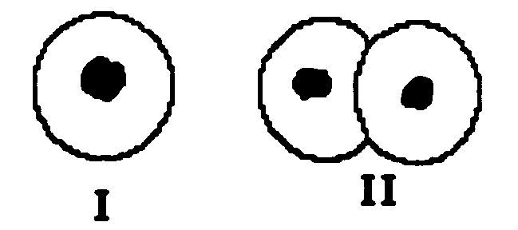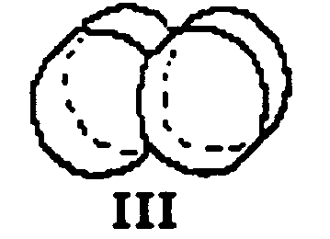

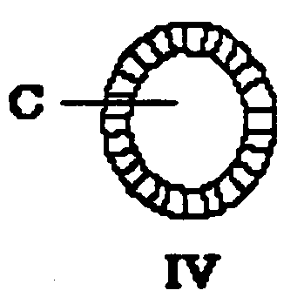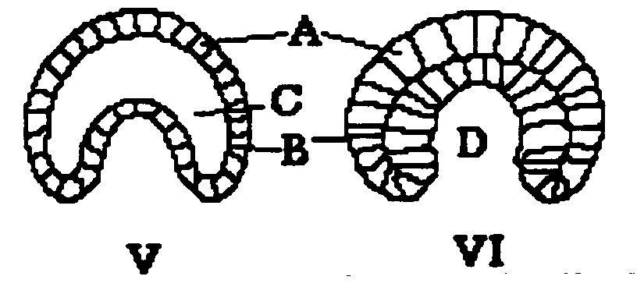

37. Between stages I and III the
A ovum and sperm will fuse.
B nucleus will undergo mitosis.
C chromosomes will divide.
D major differentiation will occur.

38. Follicle stimulating hormone causes the
A development of the corpus luteum.
B breakdown of the uterine lining.
C disintegration of the unfertilized ovum.
D development of the ovarian follicle.

39. Respiratory gases enter and leave the capillaries in the lungs by
A osmosis.
B active transport.
C absorption.
D diffusion.

40. The pancreas secretes the following substances EXCEPT
A Hydrogen carbonate ions.
B proteases.
C lipase.
D cholesterol salts.

END OF PART I
PART II : Diagram & Short Answer (80 marks)

Write answers to ALL questions on the ruled lines after each question or in the spaces provided within each table. Write your answers in blue or black ballpoint or ink pen.

41. (Total 10 marks)

(a) Primates display a wide range of locomotion methods. Each method used is the most suitable for the primate species concerned in relation to its needs and suitability to the environment. One characteristic found in all primates is forward facing eyes. What is the advantage of this feature to enhance, most if not all forms of, primate locomotion?
(3m)

(b) Some primates use a method of locomotion called brachiation. Describe the advantages of nails instead of claws, a reduced thumb and a prehensile tail for a primate that uses brachiation.
(3m)

41. (c) Comparing the diagrams of the orangutan and human foot below:

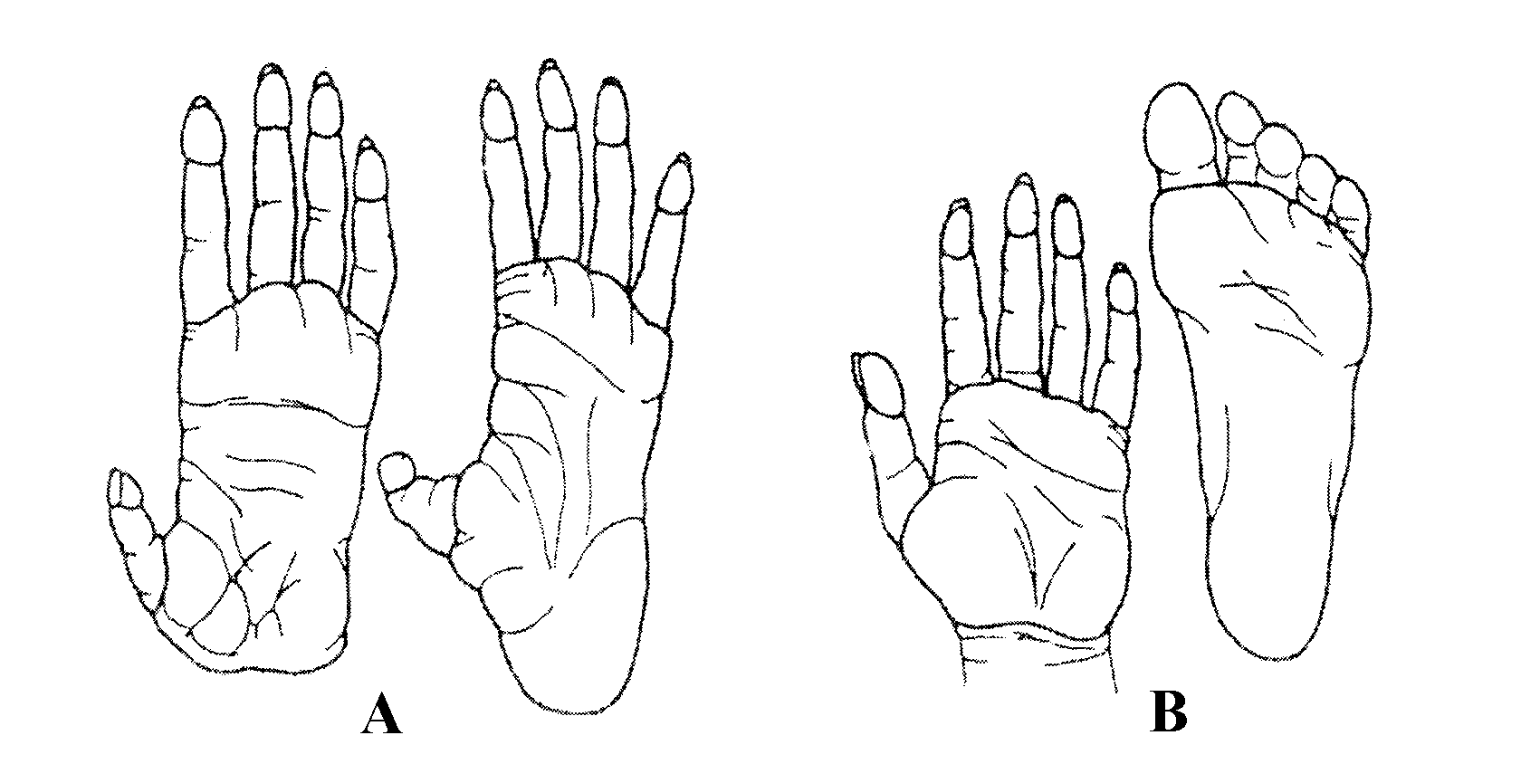
(i) Which one exhibits more digit opposability? (1m)

(ii) Describe THREE adaptations of the human foot that makes it suited to bipedalism.
(3m)

42. (Total 9 marks)

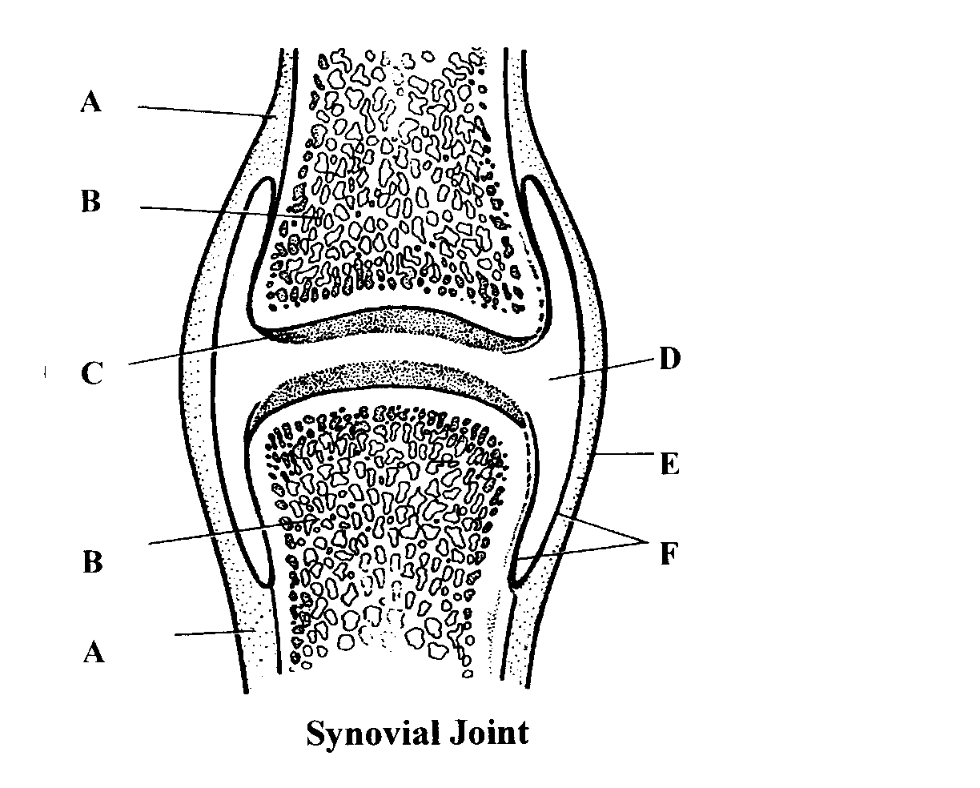

(a) Complete the following table using the diagram above.

Anatomical Term | Letter
Periosteum

Joint capsule

Articular cartilage

Joint cavity

Bone

(5m)

(b) Classify the joints listed below in terms of there structure and function.

Joint | Structural Type or Classification | Functional Type or Classification
Pubic symphysis

Knee

(2m)

42. (c) What role do the sutures and fontanelles play in the structure of the foetal skull?
(2m)

43. (Total 11 marks)
The diagram below shows the passage of red blood cells through a capillary in muscle tissue. Use this diagram to answer questions (a) and (b).

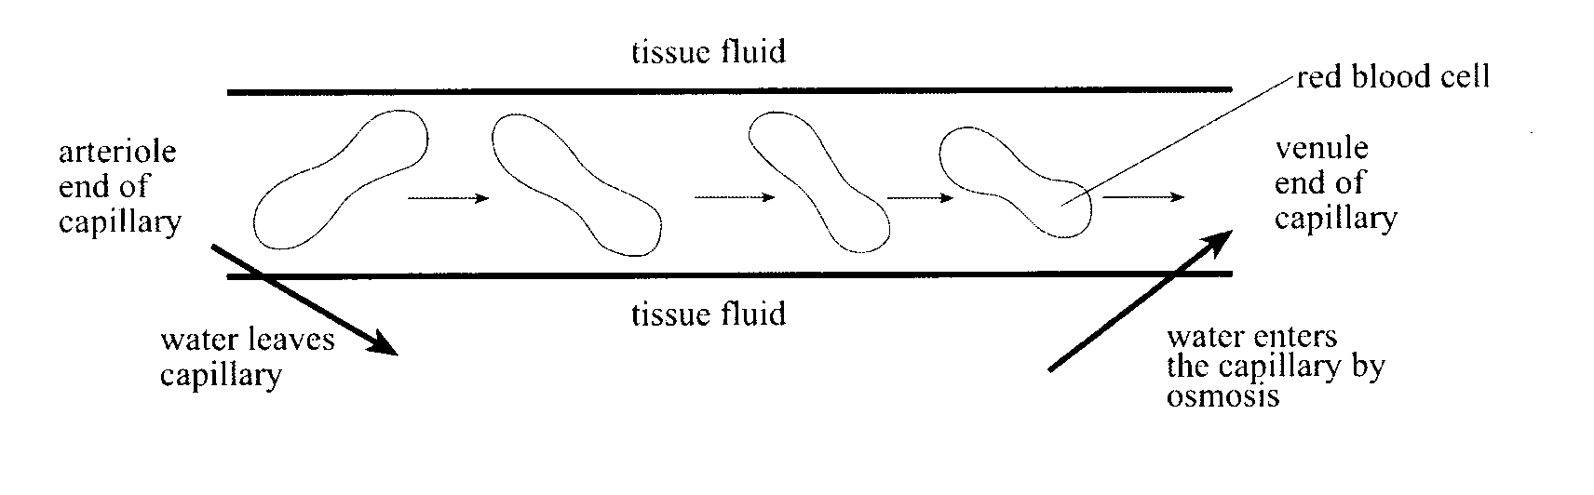

(a) Explain why water enters the capillary at the venule end by osmosis. (4m)

(b) Describe TWO ways in which the composition of the blood at the arteriole end of the capillary differs from the composition of the blood at the venule end of the capillary.
(4m)

43. (c) Describe THREE structural differences between arteries and veins. (3m)

44. (Total 10 marks)
  - Draw the most suitable graph from the information in the table below.

(Note: There is a spare page after Part III)

Deaths due to Lung Cancer in Males and Females in Australia

 | Death rate per 100 | 000 of Population
Year | Males | Females
1997  1998  1999  2000  2001  2002  2004 | 51  52  50  48  47  48  47 | 19  18  18  19  20  19  21
 (4m)

44. (b) Suggest additional data that you would need to collect before a relationship between smoking and lung cancer can be inferred.
(1m)

(c) A carcinogen found in cigarette tar causes lung cancer.

  - What is a carcinogen? (1m)

  - List THREE other carcinogenic agents. (3m)

(d) Why is it necessary to use a large sample group when conducting scientific investigations?
(1m)

45. (Total 9 marks)
Some individuals suffer a condition called heartburn or gastric reflux. This is characterised by a burning sensation occurring in the chest. It is sometimes accompanied by a bitter or sour taste in the mouth due to the acidic stomach contents refluxing upwards.

(a) Why is acid found in the stomach? (2m)

(b) Do any other digestive organs secrete acidic fluids? (1m)

(c) One cause of gastric reflux is a weakened valve between the oesophagus and stomach.

- What is the name of this valve? (1m)

(ii) What is the valve’s function in the digestive tract and name the valve that leads from the stomach to the duodenum? (2m)

45. (d) One treatment for gastric reflux is the use of antacid.
(i) What effect does this substance have in the stomach? (1m)

(ii) Will the pH of the stomach increase or decrease after the use of an antacid? Explain fully.
(2m)

46. (10 marks)
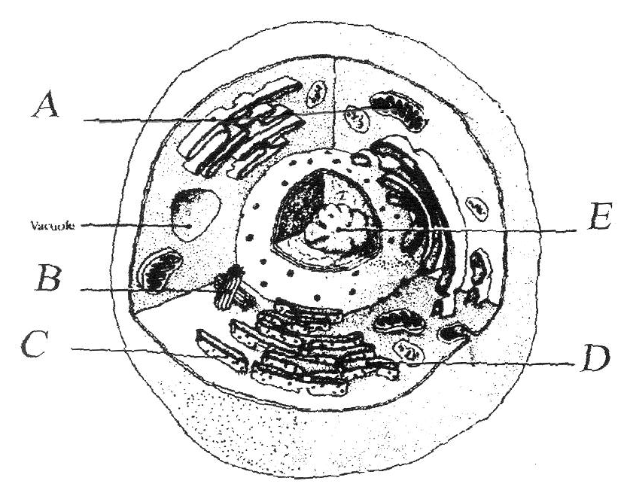

F

(attached to D)

- Complete the following table using the diagram above. (5m)

Letter | Structure
A
B
C
D
E

46. (b) What is the function of the structure labelled F? (2m)

(c) The pancreatic cells produce a large number of enzymes that are released into the gut. State which of the organelles, labelled in the cell above, would be found in large numbers there and explain why you would expect this to occur.
(3m)

47. (8 marks)
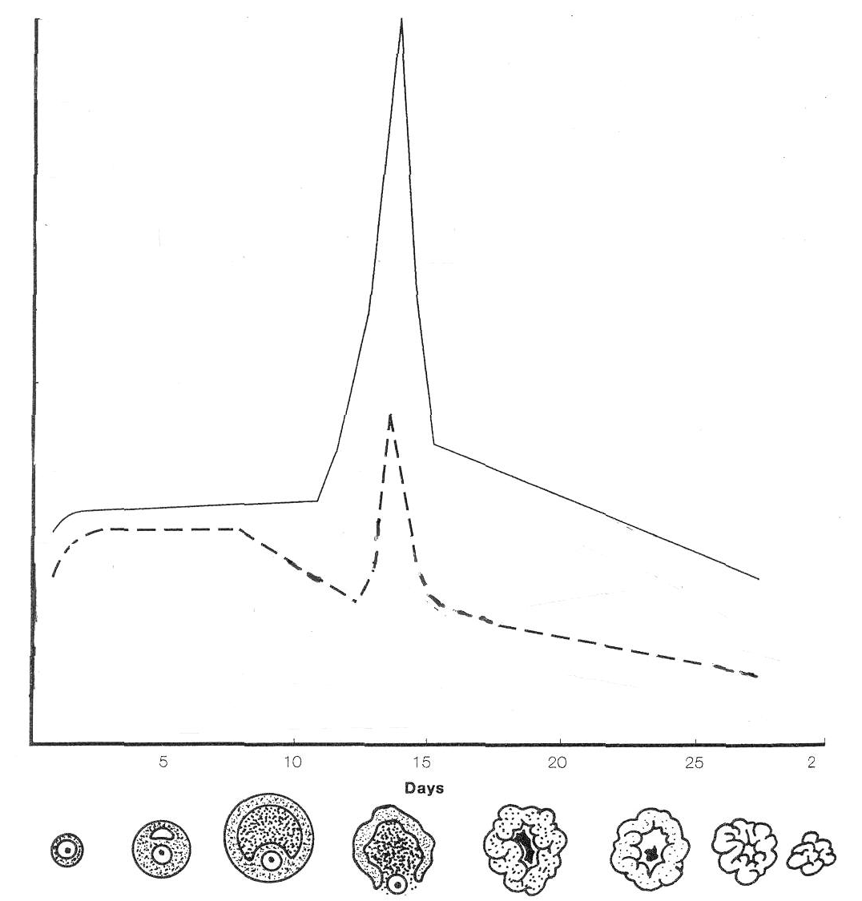
Hormone B
Hormone A

(a) Using the diagram above:
(i) Identify the female hormones labelled and for each one state the structure that produces this hormone.

Letter | Hormone | Structure
A
B
(4m)
(ii) Identify the structure shown for day 20 in the graph above and describe its function should pregnancy occur.

Name | Function during Pregnancy
(2m)
47. (b) Explain how the daily observation of cervical mucus and temperature can be used as a natural method of contraception.
(2m)

48. (Total 8 marks)
(a) Where in the female reproductive tract does fertilisation usually take place? (1m)

(b) Explain how the presence of a large number of sperm facilitates fertilisation?
(1m)

(c) What day, after fertilisation, does the blastocyst:

Attach to the uterine wall ___________________

Become fully implanted ___________________ (2m)

(d) In the following table, identify the structures labelled below.

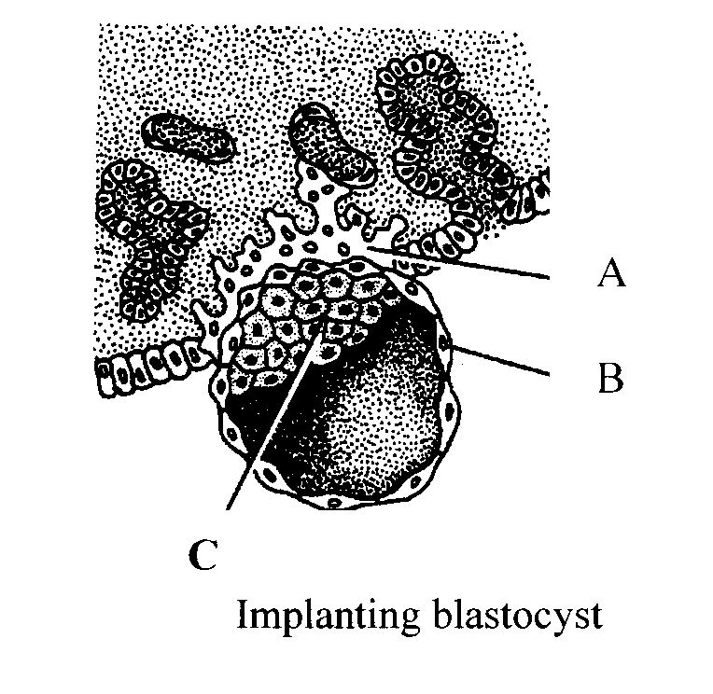
Letter | Structure
B
C

(2m)
48. (e) (i) Name the process whereby Structure C was produced. (1m)

(ii Explain the significance of this process in the development of a new individual.
(1m)

49. (5 marks)
Describe the effect of the ageing process on the nervous, circulatory and skeletal systems.
(5m)

END OF PART II
PART III : Extended Answers (40 marks)

Answer ONE question from SECTION A and ONE question from SECTION B. Illustrate your answers with diagrams where appropriate. Up to TWO MARKS may be deducted for poorly structured answers: that is, answers in point form or diagrams not explained in the text of your answers. DO NOT WRITE ANSWERS IN PENCIL. Write your answers in the Standard Answer Booklet provided.

SECTION A

ANSWER EITHER QUESTION 50 OR QUESTION 51 – NOT BOTH

50. (Total 20 Marks)
(a) Describe the breathing mechanism of inspiration and expiration. Outline the role-played by the respiratory muscles involved and the changes that occur to the air pressure in the thoracic cavity.
(10m)

(b) Discuss SIX characteristics common to the lesser ape and pongid group of primates. Contrast any TWO of these characteristics to humans.
(10m)

OR

51. (Total 20 Marks)
(a) Describe the adaptations to an erect posture exhibited by humans making particular reference to the foot, knee, pelvis, vertebral column and foramen magnum.
(10m)

(b) Humans have a specialised internal transport system linking the major organs to the cells and tissues of the body. Discuss the role of the heart, arteries and veins in this transport system. What is blood pressure and how does this change in the circulatory system?
(10m)

SECTION B

ANSWER EITHER QUESTION 52 OR QUESTION 53 – NOT BOTH

52. (Total 20 Marks)
(a) Australian Entertainer Kylie Minogue was diagnosed with breast cancer earlier this year. She like 20000 other women are diagnosed with breast cancer each year. Similarly, 2000 males are diagnosed with prostate cancer each year. What are the causes of these cancers? Explain how are they detected and describe how they can be treated?
(12m)

(b) After 40 weeks of pregnancy a baby is born. Describe the signs and symptoms of the three stages of the birthing process. If the mother decides to breastfeed her baby, discuss the function and source of hormones involved in the ‘lactation process’.
(8m)

OR

53. (Total 20 Marks)

(a) Nutrients, gases and wastes must move in and out of the cell for cells to function effectively. Discuss the movement of substances in and out of cells by diffusion, active transport and osmosis. Give ONE example of each transport method stating where it occurs in the body.
(10m)

(b) Adolescence is a time of rapid and significant change in an individual. Describe the physical changes that occur during adolescence in both males and females.

(10m)

END OF EXAMINATION

Question 44 (a )

